MUMS ON THE RUN
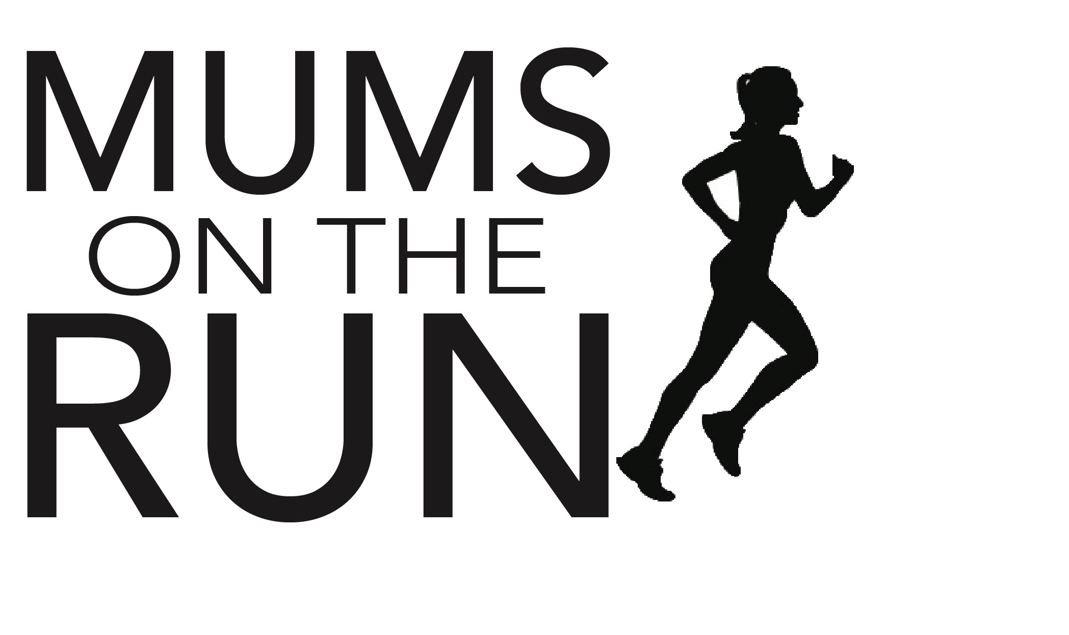
RUNNING CLUB
MEMBERSHIP FORM 2020
All members are assumed as first claim members.
Membership will run from 01 January to 31 December

PLEASE COMPLETE IN BLOCK CAPITALS AND RETURN WITH YOUR £5 CASH
ADMIN FEE OR YOU CAN BACS THE FEE!

(Fees can be sent by BACS to account 71163456 sort code 04-00-04 using your full name as reference and emailing the form to mumsontherunsol@gmail.com)
You may type in the details first, save it on your computer if desired then print it; don’t forget to sign at the bottom though!

First Name(s) |  | Last Name
Date of Birth |  | How did you hear about us?
Name/nickname I like to be known as: |  | Do you know any current members? Please list name(s)

Address

Postcode

Mobile Number

E-mail address

If you have children, please state names and ages and school attended:

Date (of application to join MotR)
Favourite Ever
Chocolate Bar:
Describe Your Biggest Running Achievement to Date (half marathon, 5km PB time, running 1 mile non stop etc):

Who we can contact in an emergency (make sure you complete the 2020 PARQ form too- ask one of the coaches for more details):

First Name(s) |  | Last Name

Relationship

Mobile Number

THE IMPORTANT BIT! PLEASE READ!

By signing this membership form, I _________________________ (print name) agree to keep and obey all rules and regulations now in force or in the future prescribed by the Club, for the use of the Club and the Club reserves the right to revoke this membership for cause if I fail to keep and obey any of such rules and regulations, or for reasons of nuisance, disturbance to other members, moral turpitude or unsafe actions that put myself or others at risk. Without limiting my obligation to obey the rules and regulations of the Club presently in force or in the future prescribed, I agree that I will obey the following rules by (this list is not exhaustive, all rules for running are contained in a separate document available on request from the Club, or found online on the Club website and social media pages):
Always considering other members' rights and privileges while I am training;
Always informing the coaches of any contraindications that may affect my training understanding that these are given in confidence;
Always advising of and updating any records where there might be a change in address, phone number, emergency contact, medication or similar;
Always understand my data is NEVER shared by the Club and any disclosures are kept strictly confidential and would only ever be shared where there is a medical or legal requirement;
Always following directions and instructions from the coaches, listening to and being present for all pre run safety briefings and asking for clarification when necessary;
Never talking, posting online or otherwise promoting derogatory comments about other members or the Club or its coaches;
Always treating the environment I run in with respect, in relation to litter, parking, pedestrians, and other road and pavement users;
Always treating members and coaches with fullest respect and courtesy at all times;
Always adhering to the Highway Code, a copy of which can be found by visiting https://www.gov.uk/guidance/the-highway-code/rules-for-pedestrians-1-to-35
Always wearing appropriate clothing and footwear designed for exercise and running
Always wearing high visibility clothing, arm bands, ankle straps, bibs or similar for all runs that take place during the hours of darkness
Always wearing Club kit when taking part in any events participated in by the Club

Without limiting the Club's ability to terminate this membership for cause, the Club may terminate this membership for any reason at any time. It is expressly understood and agreed that this contract is not assignable or transferrable by Member and no rights or privileges granted by this membership can be transferred or assigned by Member unless expressly agreed in writing by the head coach of the Club and only where there are exceptional circumstances.

It is further agreed that all running training, events, extra cross training provided by any of the coaches that are organised and attended by the Club shall be at the my sole risk. Notwithstanding any consultation on exercise programs which may be provided by Club coaches, it is hereby understood that the selection of runs, events and training plans shall be my entire responsibility if I choose to partake, and the Club shall not be liable to myself or my family for any claims, demands, injuries, damages, or actions arising due to injury to my person or property arising out of or in connection with the attendance by myself to the event or training run. Running against the advice of a coach or health professional, ignoring directions or guidance, running off the given and pre-set route, not warming up or cooling down under the direction of a coach with the Club are all examples of non conformity and therefore you will not be insured under the Club during any part of the event, training or run.

If you bring any personal property to the Club or an event or associated training run, you do so at your sole risk. It is hereby understood that the Club is not responsible in any way for damage to or loss of any personal property which you bring to the Club, gives to the coaches to look after or into any prearranged storage areas, including but not limited to, losses due to theft, damage, or car accident. I the member hereby holds the Club harmless from all claims which may be brought against them by myself, on my behalf, by my family, and my executors, administrators, and personal representatives for any such injuries or claims aforesaid and I the member for myself and on behalf or my family, executors, administrators, and personal representatives does hereby forever release and discharge the Club, its successors, assigns, owners, officers, directors, employees, and agents from all claims, demands, injuries, damages, actions, losses and expenses. This section will survive any cancellation of this Agreement.

I certify that the information given above is correct.
I have read the constitution and seasonal running rules on the MotR website www.solihullmumsontherun.uk and agree to abide by all of it.
I have read “THE IMPORTANT BIT” and understand that by signing this form, I am bound by the terms stated.
I declare that I am an amateur as defined by the UK Athletics rules and that I will abide by these rules. I am medically fit and understand that I participate/enter in any club activities/events entirely at my own risk. I agree that Mums on the Run Running Club nor its group leaders shall not be liable for any accidents, injury, loss, damage or claim or expense that may arise in consequence of my participation in club activities/events or by failing to disclose any contraindications including the changing of or taking of new medication not previously disclosed on the PARQ.

SIGNED ______________________________________

PRINT NAME__________________________________

DATE _____/_______/2020

MotR state that data will be maintained in accordance with the Data Protection Act and will only be used for internal purposes. It will not be disclosed to third parties. Ever.

